Attendance
Developing resilience in student character to attend school well.
• 100% attendance gives your child the best chances.
• If your child falls below 90% attendance they are considered to be a persistent absentee.
Why is it important for children to attend school?
Most parents want their children to get on well in life. Nowadays, it is more important than ever to have a good education behind you if you want opportunities in adult life. Children only get one chance at school, and your child’s chances of a successful future may be affected by not attending school or alternative provision regularly.
If children do not attend school regularly they may:
- Struggle to keep up with school work. In a busy school day it is difficult for schools to find the extra time to help a child catch up.
- Miss out on the social side of school life. Poor attendance can affect children’s ability to make and keep friendships: a vital part of growing up.
- Be unable to take part in trips and extra activities.
What does the law say?
By law, all children of compulsory school age (between 5 and 18) must get a suitable, full-time education. As a parent, you are responsible for making sure they attend regularly. If your child fails to attend regularly—even if they miss school without you knowing - the Local Authority (LA) may take legal action against you.
If you think you might need to take your child out of school, please discuss the reasons with the attendance team as soon as possible.
Punctuality
Setting good attendance patterns from an early age will help your child later on. Employers want to recruit people who are reliable. Children who have a poor school attendance record may have less chance of getting a good job. Students must on site by 0835.

What might the impact of poor attendance be on your child?
Research has shown that children who are not in school are most vulnerable and are easily drawn into crime. Those children who truant are more likely to offend than those that do not.
Similar research shows that 90% of pupils in secondary schools with an average of less than 8 days absence get 5 good GCSEs (grades 4+). For those with an average of 17 days or more absence the percentage drops to below 40%.

The effect of absence on your child’s education
A whole year has 365 days. A school year has only 190 days. This leaves 175 days to spend on family time, visits, holidays and other appointments.

Covid-19
If your child has a cough or a cold they can still attend school. If you are in doubt please check the government guidance and ring the attendance office and we will provide you with the information you need.

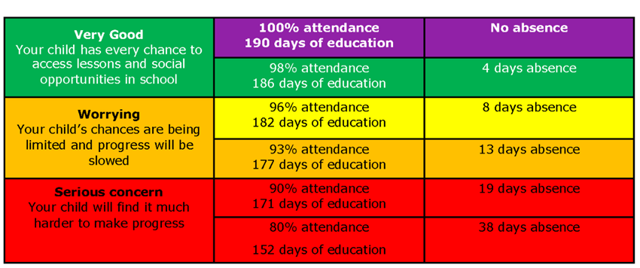

Dealing with attendance

We commit that if a child is absent with no parental/carer contract, we will send an absence text message requesting a reason and if needed, additional safeguarding checks and welfare checks will be made.

The Campion School system is based on the attendance triangle and following United Learning’s nationwide attendance 3 stage curriculum expectations.

Campion students are expected to know their attendance colour and percentage.

There are five attendance groups:

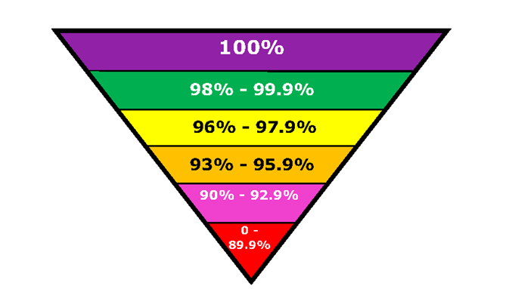

Campion School reserves the right to treat each case individually and take any necessary action within the policy to improve a students’ attendance at any stage.

What about authorised absences?
Of course there may be times when your child has to miss school because he or she is ill. Please only let your son/daughter stay at home if they are genuinely ill. Ask yourself if you would have a day off work with the same conditions.
If your child is going to be absent, please contact the school before 8.40am on (01604 833900 option 1) or email attendance@campionschool.org.uk to advise us of the reason for absence and when you expect them to return to school.
Children may also have to attend a medical or dental appointment in school time. However, you should always make routine appointments such as dental check-ups during the school holidays or after school hours. If you need to make an appointment during the day, it is better to get your child into school for some of the day than miss a whole day. Any absence must be requested as far in advance as possible. Absences can only be authorised by the school.
NHS and Public Health England Guidelines for illness:
Condition | Comment
Covid-19 | Follow the latest government guidance on self isolation if you are displaying any symptoms
Vomiting and diarrhoea | A child should be kept off school until after their symptoms have gone.
Cough / cold | A child with a minor cough or cold may attend school. If the cold is accompanied by a raised temperature, shivers or drowsiness, the child should visit the GP.
Headache | A child with a headache doesn’t need to be kept off school. If the headache is more severe or is accompanied by other symptoms, such as raised temperature or drowsiness, then visit your GP.
Period Pain | Attendance at school should not be affected. If necessary allow the child to take painkillers. If these are ineffective, your GP may prescribe a stronger painkiller.
Rash | Rashes can be the first sign of many infectious illnesses, such as chickenpox and measles. Children with these conditions shouldn’t attend school. Consult your GP.
Head lice | Children can attend school with head lice however they must be being treated to stop it spreading.
Conjunctivitis | It is not necessary to miss school if they have bacterial or viral conjunctivitis.
Tonsillitis | It is not necessary to miss school. There are many causes, but most cases are due to viruses and do not need antibiotics.
Impetigo | Your child cannot attend school until lesions are crusted and healed, or 48 hours after starting antibiotic treatment. Antibiotic treatment speeds heading and reduces the infectious period.

The world is run by those who turn up

- Attending school every day = 100% attendance.
- Attending 4 ½ days a week = 90% attendance = 20 days missed a year.
- Attending 4 days a week = 80% attendance = missing over half a term.
- An average attendance of 90% or less across a child’s school career adds up to missing over a whole year from school.

Being late for school reduces learning time
- If your child is 5 minutes late every day they will miss three days of learning each year
- If your child is 15 minutes late every day they will miss 2 weeks of learning each year.

Make every minute count

